Task🡪 **Sanity Check**

Challenge Type**🡪** Cryptography

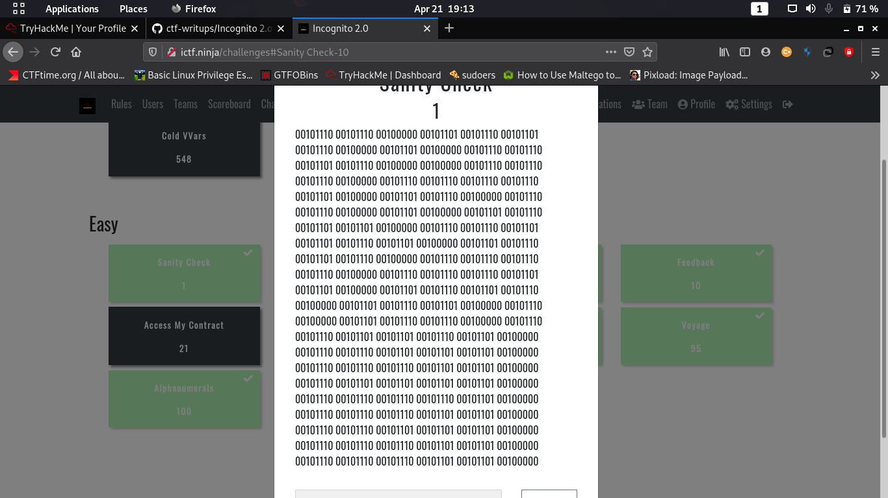

1. go to <https://gchq.github.io/CyberChef/>
2. select filter binary->ascii
3. copy and past the give code
4. It will return morse code
5. Now copy and morse code and change filter to

Morse->ascii

1. It will return the flag!!!!!!!!!